**Project Design Phase-I**

**Solution Architecture**

|  |  |
| --- | --- |
| Date | 20 October 2022 |
| Team ID | PNT2022TMID20272 |
| Project Name | Project -IOT BASED SMART PROTECTION SYSTEM FOR AGRICULTURE |
| Maximum Marks | 4 Marks |

**Solution Architecture:**

System that is built for monitoring the crop field with the help of sensor. The IOT device is used to indicate The farmer by a message while someone enter into the Farm and we are used SD card module that helps to Store a specified sound to fear the animals. The announcement of the threshold rate will be sent to the cell number or to the website. The result will be generated on a catalog if the mobile of the person to take the necessary action.

**Example - Solution Architecture Diagram:**

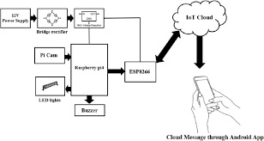

**Smart crop protection**